**Say hello to mproHealthcare** 

We are excited to introduce the new and improved home treatment scanning app for people on home treatment with clotting factor concentrate. All users can download **mproHealthcare** from the Apple App Store and Google Play store.

The goal is to provide users with improvements to the app which will make the experience easier and more useful. All of the current functions remain and the following new features have been added

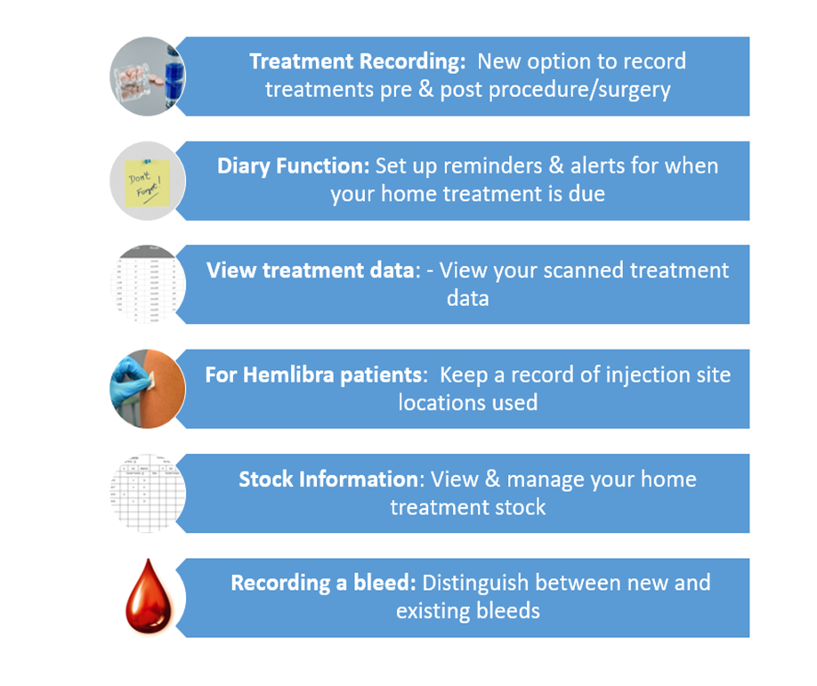

T**o continue scanning your treatment, it is important that you download the new app mproHealthcare.**

Your local Treatment Centre Team are on hand to help with any queries or issues that you may encounter.

Thank you for your continued use of the home treatment scanning app. We welcome your feedback and comments as we move to **mproHealthcare**

**Please check out the User Support Videos and user guide below for the mproHealthcare app**

**User Guide User Guide Video – New Features User Guide Treatment Video**

**  **

**Download the app now! - Scan the appropriate QR code with your smart device, and download the app, for free!**

**Apple Android**

